Seals Faculty Web Page

Contemporary Web Design in Academia

Theo Zinner  
tvz0001@auburn.eduAuburn University

Leah Lee  
 jzl0213@auburn.edu  
Auburn University

Harley Grace hkg0005@auburn.eduAuburn University

Byron Prather  
bjp0017@auburn.eduAuburn University

1. ABSTRACT

The purpose of this project is to create a new website for Dr. Seals. This will include updating existing sections of her website and creating new content. This website will reflect current design principles being taught in her user interface design and evaluation class along with current information about Dr. Seal’s Curriculum Vitae, Projects, and academic involvement. This paper will discuss the process and approach that will be taken in development along with current progress and a literature review.

1. **Literature Review**

Multiple aspects were considered when researching this project. The subjects considered are as follows.

* 1. Byron Prather

“Aesthetics and Usability: A look at Color and Balance” [1]

This research essay contends that two of the most important factors in attracting users to a site are color and balance. An appropriate combination of colors that not only draw interest but complement each other is important. Balance is also important. Balance considers the website’s layout or sense of equilibrium. Color and balance influence what they call “harmony” in a design, and that a harmonious website engages the viewer and creates an inner sense of order. We want our site to be aesthetically pleasing by reaching this harmonious state.

By testing a group of 80 volunteers they presented them with 4 webpages. One which was the original site, one where the balance was shifted more outward, one where the color pallet was changed from blues and whites to pinks and lime greens, and one where the color and balance was shifted. They asked the testers to use each of these sites at different intervals and rate their satisfaction both aesthetically and in perceived usability. What they found is that the original site was the most popular in both categories. It was aesthetically more pleasing with its neutral blues and whites over the harsher and more dramatic light pink and green. And it swept the contest in perceived usability too, rather than spreading the information out evenly across the page, the original site opted to keep it more condensed around the middle of the page, using the center as the focal of its balance.

It is difficult to nail down exactly what it means to be aesthetically pleasing. But it is important to consider the mix of colors and a sense of balance when creating a web design. This combination referred to as “harmony” can make a user’s experience on a website great or awful. We seek to find harmony for this project as well.

* 1. Harley Grace

“Influence of faculty- and web portal design-related factors on web portal usability: A hierarchical regression analysis” [2]

The study analyzed the effect of certain design factors on the usability of faculty web portal usability using hierarchical regression analysis. This study was selected due to its similarities to our software and due to the importance and relevance of its findings regarding accessibility. Of the study’s findings, one with particular importance is the conclusion that commitment was a strong positive that could push older people to use technology over the internet, and that user age positively influences usability if the user is also committed to using the portal; this implies that focus should be placed on encouraging commitment. Additionally, the finding that information content’s high influence on usability is significant to note, as it implies that the other design factors have a significantly lower impact on usability.

To solve the subject of the study’s research, independent variables were organized into two constructs, faculty-related factors and web portal design-related factors, with faculty web portal usability as the dependent variable. These variables were used together with five null hypotheses to create the research framework used in the study (pictured in Figure 1). This data was collected using survey responses, with each qualitative measure being recorded on a 5-point scale (1-lowest, 5-highest) for each item. After statistical analysis and hierarchical regression, it was found that while most of the users of web portals are of younger age (early 40s), there were users of older age who were committed to using the web portal. These users reported that they recognized the web portal was designed for “ease of use, information content, availability, speed, and aesthetics.” This information, combined with the analysis of the other factors and the observation that commitment to the use of the web portal and information content influence web portal usability, allows the last two null hypotheses to be rejected, while the first three are accepted.

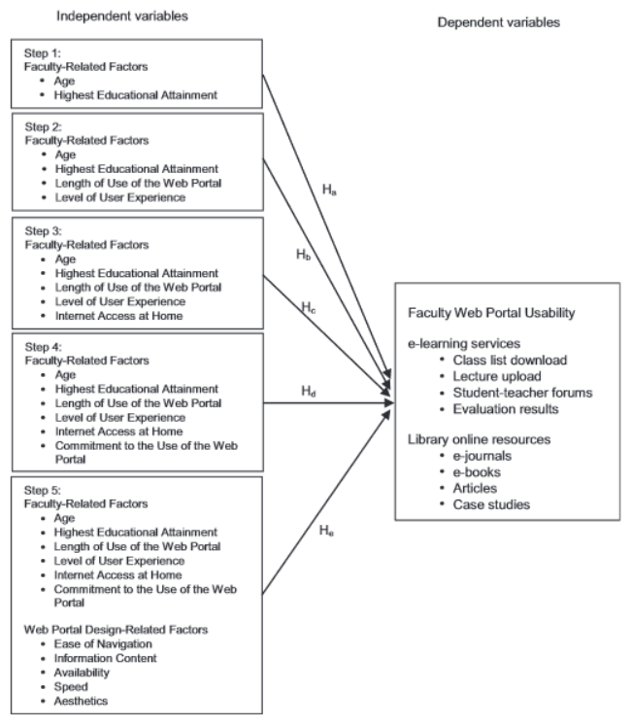

Figure 1

* 1. Leah Lee

“Usability issues in website design” [3]

There are problems to find specific content on several websites. The reasons are organization-centered, printed form-focused, and not subject to the traditional forms of publishing. The author sums up that a successful web developer requires the combined skills of domain expertise, HTML, graphic design, and web usability. The author also provides subtitles of each sub-topic of this paper that are planning, site structure and content, support navigation, page design, evaluation methods, and management and maintenance, respectively.

First, planning focuses on provider requirements, user requirements, and key scenarios of use. To be specific, setting usability goals, identifying user groups, investing accessibility by users with disabilities can be considered in planning. Second, the site structure and content section point out the structure information, content information, and writing details. For the website structure and content, surveying or interviewing users can be conducted for how to categorize information on the website. The order of conclusion or restriction of white-spacing can be set for the writing style. Third, the support navigation section includes “help users find their way” and “tell users what to expect.” ‘Showing users where they are and where they can go’ or ‘use a consistent page layout’ can be examples of the formal part of this section. ‘Provide a site map or overview’ or ‘give sizes of files that can be downloaded’ can be examples of the latter part of this section. Fourth, page design introduces effective home page design and readability of texts. Also, a particular example that is supporting a text-only browser is provided in this section. The reason for supporting a text-only browser is that some users can turn off the graphics because of increasing speed. Fifth, the evaluation methods section talks about expert inspection, early mock-ups, and functional prototypes. A checklist can be helpful for the consistency of the style. Mock-ups and prototypes will represent the website and can be used for evaluating or getting feedback. Sixth, the management and maintenance sections explain the criteria of the quality and usability requirements for new pages, indexing, and maintenance of the web site. Some automated checking can be used when adding new pages. Indexing important topics help users find the website. Some style guide for each page can be helpful for page developers. Getting feedback from the user and checking broken links are considered in maintenance.

To have a better quality of a website, those six sub-topics can be considering, and checklists of each sub-topic can be useful for evaluating the website.

* 1. Theo Zinner

“Cultural Impact on Website Design: A Study in India and USA” [4]

One needs to first and foremost consider the user when designing a website. In this case, the website being designed will be used by people with different cultural backgrounds. Considerations for other cultures need to be made to make this website inclusive and easy to use for everyone. "Cultural Impact on Website Design: A Study in India and USA" investigates differences in design in American and Indian culture.

This paper investigates user behavior and satisfaction using a website across different cultures. Before getting into the cultural aspects of web design some groundwork had to be done to define cultural dimensions that can be compared. These cultural dimensions included: Powder Distance Index, Individualism Vs. Collectivism, Masculinity vs Femininity, Uncertainty Avoidance Index, Long-Term Orientation vs. Short-Term Orientation, and Indulgence vs. Restraint. These dimensions were all categorized and measures on a scale from 0 to 100 for comparison. These cultural indices can have a great impact on web design according to this paper. It focused primarily on the difference between America and India [3] here is a chart with the indices for each country considered:

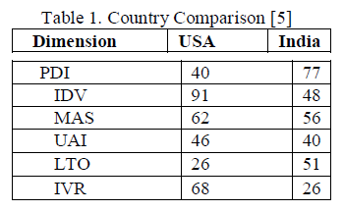

The hypotheses are that users from India will prefer a website that emphasizes the Power Distance Index, this is the idea that less powerful members of a group accept an unequal distribution of power. A higher score implies this while a lower score implies that members of society are more independent to make their own choices. The experiment conducted used Adobe XD to create two mockups of the Adidas website from both America and India. The XD models were then both translated into the languages from both countries and were then given to participants in the study for feedback. This study illustrates how usability may have different considerations in different cultures. Cultural differences are something to consider when creating a website that will serve students from all over the globe.

2.5. Byron Prather

“A Review of the User-Based Web Design: Usability and Information Architecture.”[5]

This paper is a review that seeks to outline techniques and standards for web-based design. It breaks the design process down into the planning phase and the design phase.

In planning the objectives of the site are identified, as well as the needs and objectives for our prospective audience. Using this we can begin to detail the back end and front end of our requirements, and how to achieve them with our budget, both concerning money and time. The purpose of the website is to balance the needs of the user and the provider. Our planning is based on the collection and analysis of possible information with a solid base for our site.

The design stage is broken down into many different parts starting with user modeling. In this part, we obtain as much information as possible about our users from our user studies so we can determine what we need to provide for them. But be careful if your audience is too large and heterogenous, because then this phase is mostly pointless, as many audience members will be the same. Next comes our conceptual design, we are very familiar with this so I’ll quickly move past it and jump into the more interesting elements that come after.

Then is Visual Design and Style definition. In this phase, we look at the visual aspect of our website and specify what type of composition we want to use on each page and the element of interaction. We must consider a visual hierarchy of importance. We can use many things to signify how important an element is, such as the size or space occupied by the element, the use of color contrast to distinguish it from the surrounding information or area, relief and depth, typographical effects, and more. In this realm, we must also consider accessibility. In our use of color, for example, we must make sure to have a good contrast between text and background such that someone who is color blind would still be able to easily read it.

Then there are prototypes which we are also familiar with. In this segment four types of prototypes are defined according to a level of functionality, Horizontal, Vertical, High Fidelity, and Low Fidelity prototypes; for example, paper wireframes are low fidelity as they are open to change and take little to no cost to produce. What is important is to scale up the prototypes in proportion to the design phase you are in.

Lastly, we must evaluate our design in many areas. We want our design to be recognizable, flexible, minimalist, helpful, and consistent. To make certain of this we use usability testing. We have covered many usability testing methods in a class, so I won’t go overboard here. The important takeaways are the new ideas of Visual Design and Style definition and the four types of prototyping.

1. **Methods** **and** **Implementation**
   1. Specification and Requirements

The team decided on using a waterfall approach for the development of this project. This approach is in line with the somewhat short development deadline and team dynamic. The first step to building this project was meeting with the client, Dr. Seals to learn about project specifications. After meeting with Dr. Seals to understand what needed to be added or updated on her site an empathy map and personae were created by Byron Prather and Harley Grace to understand her goals for the new website. The next step was conducting a literature review to research contemporary design considerations and methods. Finally, a wireframe was created to serve as a mockup for the full implementation of Dr. Seals' new web page (Figure 1).

*Figure 2*. Wireframe

The wireframe was created by Theo Zinner and Leah Lee to meet specifications given by the empathy map and personae. The wireframe will be reviewed by Dr. Seals so that it can be revised to meet her needs in both design and content. The current specifications are that the website needs to include the following sections:

1. About

The About page contains Dr.Seals’ headshot, a brief bio, contact information, education, and academic positions.

1. Teaching

The Teaching page contains classes that Dr. Seals teaches along with descriptions, the term, and the course number.

1. Students

The Students page contains a list of graduate students studying under Dr. Seals with headshots, links to their LinkedIn pages, and projects they are working on.

1. Involvement

The Involvement page contains outreach and programs that Dr. Seals is involved in and links to external pages about the aforementioned programs.

1. Projects

The Projects page contains a carousel section that shows all the projects along with a description for each project.

1. Publications

The Publications page contains a search feature and a list of publications.

3.2 Conceptual Model Description

*Figure 3*. About

*Figure 4.* Teaching

*Figure 5.* Students

*Figure 6.* Involvement

*Figure 7.* Project

*Figure 8.* Publication

The structure was informed by Leah Lee and Theo Zinner, and the prototype was created by Leah Lee. Our prototype has a similar structure to the previous team. The logo is in the top left and the title of the website is located in the top middle. On the ‘About’ page, the headshot, slide show, contact, and bio come first. When scrolling down, highlights can be seen. On the ‘Teaching’ page, the teaching statement and the information of the current classes can be seen without scrolling. On the bottom of the teaching page, the information about previous classes is shown. On the ‘Student’ page, current Ph.D. and Mater’s students’ names, projects, and years are listed. On the ‘Involvement’ page, some of the events are listed in a box format. Also, the external link is at the bottom of the page. On the ‘Project’ page, the project picture, title, and description is in a carousel format. On the ‘Publication’ page, the publication image, title, writer, and description are shown in a box format. There is a search feature as well. After searching, the view will be changed as a listing view. The color theme of the website is dark blue and orange such as Auburn University’s official colors.

* 1. Software Requirements

The redesigned site should be simple, and thus should load and run as expected given the following basic requirements are met:

* The HTML5-compatible browser from the last decade or so
  + Internet Explorer 9 & 10.
  + Firefox 7 and higher.
  + Chrome 14 and higher.
  + Safari 5 and higher.
  + Opera 11 and higher.
  + Mobile Safari 3.2 and higher.
  + Opera Mobile 5 and higher.
  + Android 2.1 and higher.
* GUI

1. **Evaluation and Result**

4.1 For our evaluation we created a survey on google forms. The survey includes a pre-questionnaire that gets the basic demographics of the survey taker. Next, they will answer some questions about Dr. Seals' website this will allow the users to get familiar with the website. Finally, they will answers questions based on their experiences. From these answers, we found out what the users liked and didn’t like about the old website. Below is an example of the feedback we got on one of our questions. The old website still had most of what it needed. However, some things were not up to date.

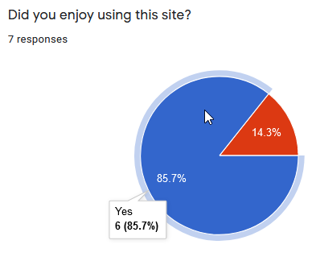

4.2 We will compare the page against other faculty members of auburn and other select universities. This will help us determine if our site has all the desired functionality. Additionally, we will test all possible paths through the website. Thereby, evaluating all possible decisions a user can make.

1. **Discussion and Conclusion**

The most important part of this project is to talk to the customer and gather requirements. The easiest way to do this is to have multiple meetings throughout the development process in which we demo our work to the customer. Frequent demos will ensure that the final product is what the customer truly wants and will allow any changes that need to be made happen.

We had a meeting with Dr. Seals to go over our wireframes and website designs.

1. **Future Work**

Future teams can work on adding interactive details. For example, dynamic interaction that changed when a user interacts with it a certain way, such as positioning their mouse over it. Also, future teams can add more content that Dr. Seals is involved in the involvement page and update the course, student, project, and publication information on the website.

**REFERENCES**

[1] Brady, Laurie, and Christine Phillips.

"Aesthetics and usability: A look at color and balance." *Usability News* 5.1 (2003): 2-5.

http://citeseerx.ist.psu.edu/viewdoc/download?doi=10.1.1.499.5443&rep=rep1&type=pdf

[2] Bringula, Rex P. “Influence of Faculty- and Web Portal Design-Related Factors on Web Portal Usability: A Hierarchical Regression Analysis.” Computers &amp; Education, vol. 68, 2013, pp. 187–198., doi:10.1016/j.compedu.2013.05.008.

[3] Bevan, Nigel. "Usability issues in web site design." HCI (2). 1997.

https://d1wqtxts1xzle7.cloudfront.net/28350309/usability-issues-in-website-design-1.pdf?1348448290=&response-content-disposition=inline%3B+filename%3DUsability_issues_in_web_site_design.pdf&Expires=1603784335&Signature=eRuvd7MUuowWcEC4siS7Owvr6xo-zzPsmPKa6dFt9z4vGmRdjzEry~OqSjZjLgR77SakjH1CG9jZjcJ8Hh5M6ij2KkRizWNW7RWaZICSZTkqgTZ7CBmq0yoV3AtYpM0ipsg9mJUdDYCa5zICMQDGQYe-xXM~m7fTW1tusHuh6yLfBCAA6u9M~KWRZDhFerLmXfwyuOAaDvfY0mnWwihR-vNrLQc7mOdW5LcRPv6MMiAcG1tRo2wX0Qo1m0wko0RxUTRBzYOMQAJdM1SvlGm8MqlP-DV22Q-SsSOmYWK4N7YbX2s7fjdsn2dvXbf0akm4Y9BmX3-7ZBdk1bKIro1D3w__&Key-Pair-Id=APKAJLOHF5GGSLRBV4ZA

[4] Panchal, Khushboo, Kristen Ray, and Damian Schofield. "Cultural Impact on Website Design: A Study in India and the USA.” https://www.researchgate.net/profile/Damian_Schofield/publication/341105582_Cultural_Impact_on_Website_Design_A_Study_in_India_and_USA_American_Journal_of_Humanities_and_Social_Science_Research/links/5eadba5c299bf18b9590f244/Cultural-Impact-on-Website-Design-A-Study-in-India-and-USA-American-Journal-of-Humanities-and-Social-Science-Research.pdf

[5] Perdomo, E. García, et al. "A Review of the User Based Web Design: Usability and Information Architecture." International Journal of Applied Engineering Research 12.21 (2017): 11685-11690. http://www.ripublication.com/ijaer17/ijaerv12n21_160.pdf